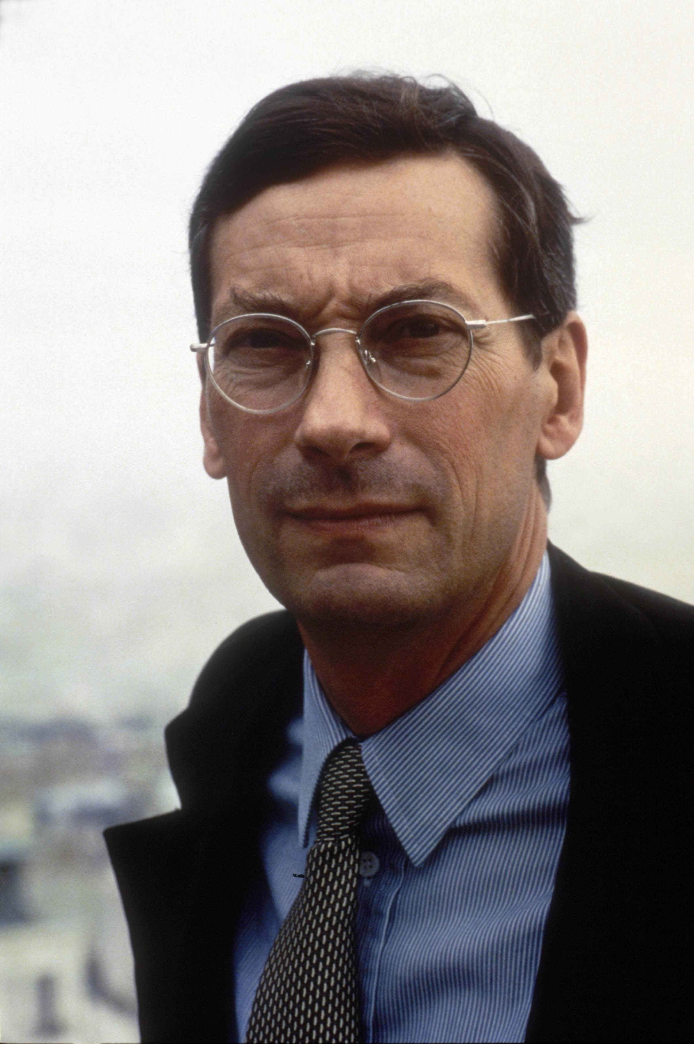 | ALFRED PACQUEMENT  Director and chief curator of collections, Musée National d’Art Moderne, Centre Georges Pompidou  After completing his studies in art history at the University of Paris, Pacquement became Chargé de Mission at the Centre National d’Art Contemporain, where he curated his first exhibitions. He was also curator of the 7th Biennale de Paris (1971) and of “72-Douze ans d’art contemporain en France” (1972).  He joined the staff of the Centre Pompidou, where he became curator of the Musée National d’Art Moderne in charge of contemporary art (from 1974 to 1987). He was then appointed director of the Galerie Nationale du Jeu de Paume (1990-1993). He was Délégué aux Arts Plastiques at the Ministère de la Culture et de la Communication (1993-1996), and director of the École Nationale Supérieure des Beaux-Arts from 1996 to 2000. In September 2000 he was appointed director of the Musée National d’Art Moderne, Centre Pompidou.  Curator of many exhibitions in France and abroad, Alfred Pacquement is also an art critic and an art historian. He has published books on Frank Stella, Richard Serra, Henri Michaux, Claude Viallat, as well as a number of essays on French art.  He has been a member and president of the jury of the Prix Marcel Duchamp since its inception in 2000 and has been a jury member of the Turner Prize 2002.  He is a member of the AICA (International Association of Art Critics) and of ICOM (International Council of Museums).  In October 2004 he was elected president of the CIMAM.

