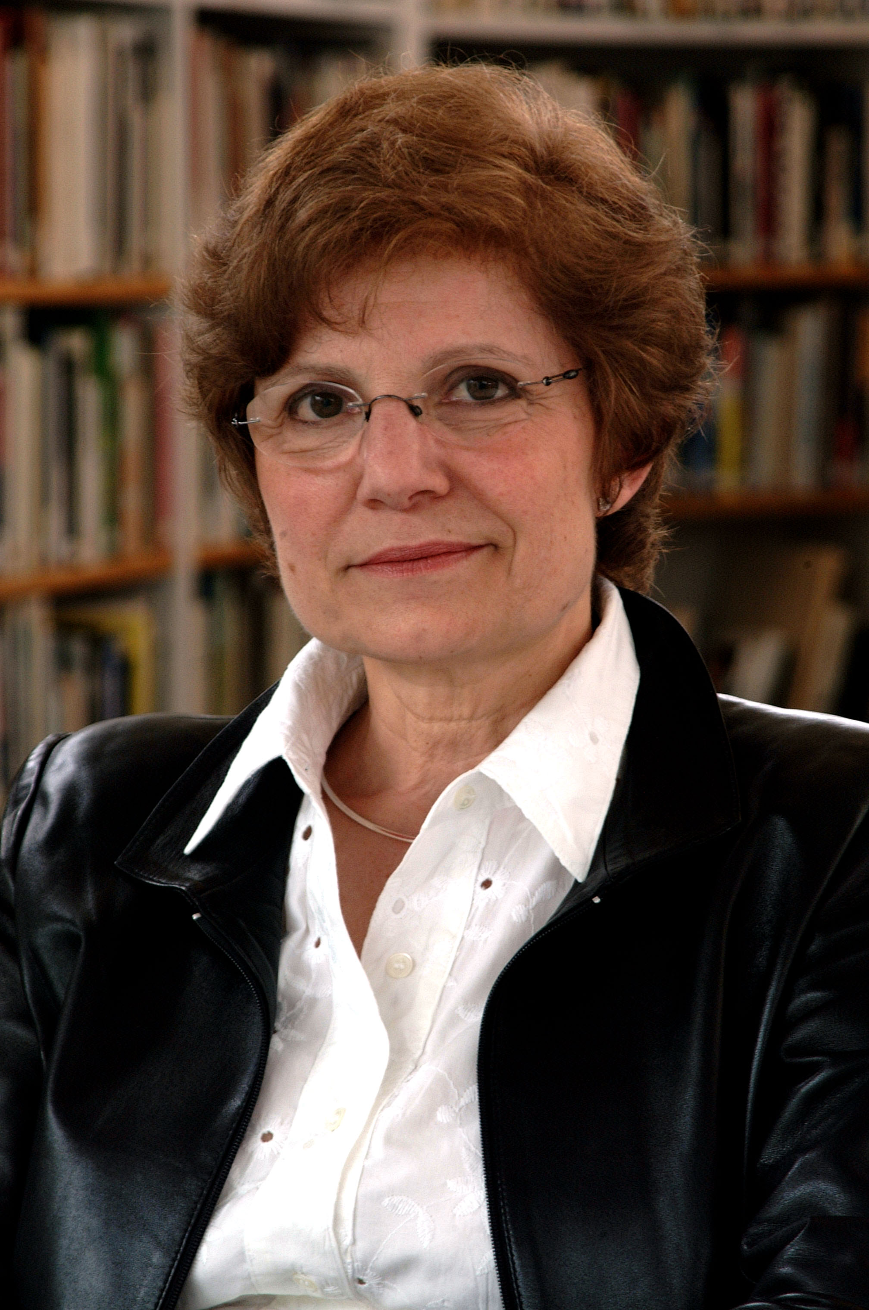 | ROSA MARIA MALET  Director of the Joan Miró Foundation, Center of Contemporary Art Studies, in Barcelona.  She obtained her degree in humanities with a major in art history from the University of Barcelona. She started her professional life at the Joan Miró Foundation in Barcelona in December 1975.  Since October 1980 she has been the director of that institution. A Joan Miró specialist, she has organized several Miró exhibitions such as that which commemorated the centenary of the artist’s birth.  She is the author of Joan Miró (Edicions Polígrafa, 1983), Els cartells de Tàpies (Edicions Polígrafa, 1983), and Joan Miró. Una biografia (Edicions 62, 1992).  She is a member of the AICA (International Association of Art Critics), the ICOM (International Council of Museums) and of CIMAM (Comité international des Musées d’Art Moderne), a branch of ICOM.  She has been a member of the jury of the Premios Príncipe de Asturias de las Artes on several occasions (in 1994 and from 1999 to 2002).  Since 2005 she is a member of the Board of the Royal Academy of Spain in Rome and is also a member of the Committee of Authentication of ADOM (Association pour la défense de l'oeuvre de Joan Miró)

