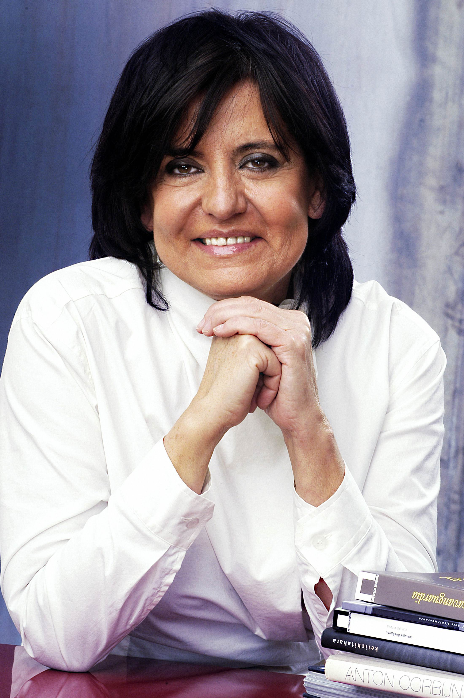 | IDA GIANELLI  President of Azienda Speziale palaexpo in Roma.  Director of Castello di Rivoli Museo d’Arte Contemporanea in Turin (Italy) till 2007.  In 1970 she collaborated in the exhibition "Arte Povera Land Art Conceptual Art", Galleria Civica d'Arte Moderna di Torino, and in the publication of its catalogue.  From 1972 to 1979 she directed and curated the exhibition program of the Samangallery in Genoa, where she combined shows of American artists with shows of European artists.  Between 1980 and 1984 she worked as a free-lance curator.  From 1985 to 1990 she was assistant curator to Pontus Hulten, artistic director of the Palazzo Grassi in Venice.  In November 1990 she was named director of Castello di Rivoli Museo d'Arte Contemporanea.  In 1997 she was appointed member of the Scientific Committee of the XLVII Biennale di Venezia.  In 2000 she was appointed Officer of Culture by the French Republic.  In 2005 she joined the Louvre Museum commission that selects international artists to make works for the Parisian museum. She is also part of the Scientific Committee of the Museu Serralves in Porto (Portugal), and of the acquisitions committee of Tate Gallery in London.  She has been a member of several international juries.  She is the curator of the new Italian Pavilion for the 2007 Venice Biennale.

