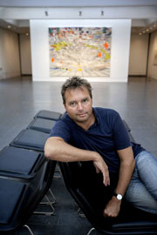 | POUL ERIK TOEJNER  Director  Louisiana Museum of Modern Art, Humblaebeck  Since 2000: Director of the Louisiana Museum of Modern Art, Director of the Louisiana Foundation and Director of the Museum Foundation  1997-2000: Member of Editors-in-Chief (weekly newspaper “Weekendavisen”).  University education: Master’s degrees Mag. art and cand. mag in Nordic Philology (1987) and Philosophy (1981). Licentiate degree Lic. phil. with a dissertation on Søren Kierkegaard. Author on several books on art and literature.  Among other things member of the board on: Gyldendal (Denmark’s biggest publishing firm), C. L. David Foundation, The Danish Academy.  Adviser for international institutions, a.o.t. a new Renzo Piano museum building project in Oslo, Norway (expected opening in 2011).  Profile  Throughout his studies Poul Erik Tøjner has worked across disciplines – philosophy, art, literature and architecture. He has published books on all these subjects and for several years he worked as a writer on literature and art for various Danish newspapers. In addition Poul Erik Tøjner is a member of a number of Danish and international boards, which brings him into contact with artists and colleagues all over the world. Architecture plays a special role in the Louisiana Museum’s exhibition profile, and the institution is itself famous for its distinctive fusion of art, architecture and landscape.  Publications:  Has written several articles and books on literature, art and philosophy, including “Per Kirkeby – Paintings” and “Per Kirkeby – Sculpture”, “Munch: In His Own Words”, “Roy Lichtenstein: All about Art”, “Cézanne and Giacometti”.

