Commemoration of the twenty-fifth anniversary of the death of Joan Miró.

2008-2009

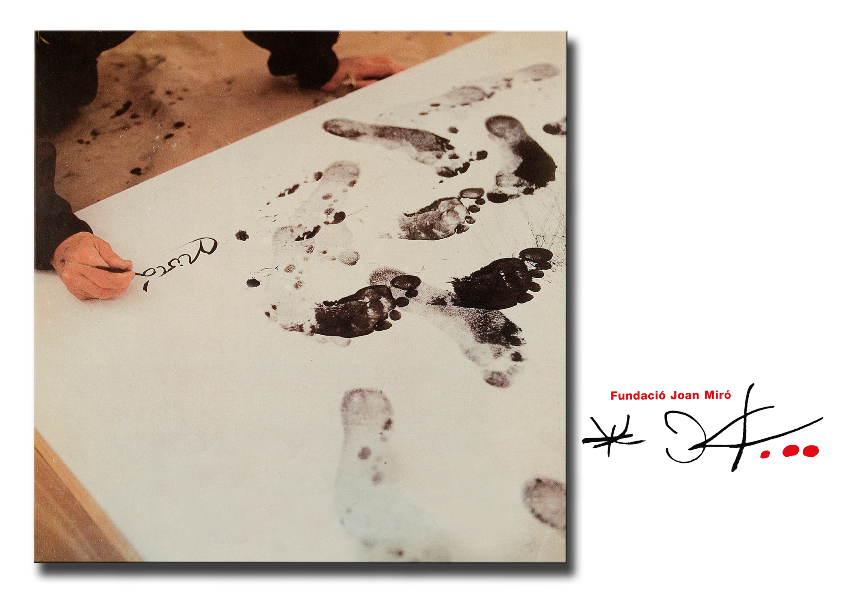

“[...] let it all then be carried away by the wind, the water, but be sure that all these pure actions of my spirit will by magic or miracle have an effect the spirit of other men.”
Joan Miró: Anotacions, 1941. Col·lecció Fundació Joan Miró

On 25 November, the Joan Miró Foundation will be commemorating the twenty-fifth anniversary of the death of Joan Miró (on 25 December 1983) with a talk by Dr. Robert Lubar on “Joan Miró’s artistic legacy” in the Auditorium.

The commemorations also include a variety of activities and events designed to provide a knowledge and understanding of the artist’s work, to encourage in-depth study of the origins and creative process of his art, to promote and disseminate academic studies and critical appreciations of his life and work, and above all to demonstrate how valid his contributions to art still are today.

Since it was set up, the Foundation has kept these goals very much in mind and recently has taken steps to enlarge its documentary resources with a view to facilitating the work of researchers.

This commemoration, therefore, should not be considered as either a beginning or an end in this respect, but as a continuation of the work already started and a renewal of the commitment to pursue this path without neglecting other aspects of contemporary art.

LONG-TERM PROJECTS

The Foundation has helped to publicise its exceptional collection of Miró’s art through permanent exhibitions on a rotating basis, by organising loan exhibitions and other shows relating to specific aspects of his work, and by encouraging research on the artist.

With these aims in view, the Foundation has carried out the following projects:

- Joan Miró's Private Library
A particularly important undertaking that has involved incorporating into the Foundation’s resources the 1,743 volumes on permanent loan from the artist’s family.
The private library consists mainly of universal works of literature in Catalan, French and Spanish; books relating to the world of Surrealism, many of them inscribed by their authors, and on art theory and criticism, mainly from the 1920s and 1930s.
This exceptional collection gives us a better understanding of the importance Miró attached to reading in his creative work and enables us to appreciate his art more easily.

- Digitalisation of Miró’s drawings
Thanks to an agreement with the Fundación Telefónica, the documentary resources held by the Foundation, consisting of over 13,000 inventoried items – drawings, notes, models and correspondence – have been digitalised. This means that they will be able to be included in the database.

- New website
The Foundation’s website – www.fundaciomiro-bcn.org – has also been completely overhauled, thanks to BBVA’s sponsorship, in order to provide easier access to all information on its activities and on the collection of Miró’s works.

- Espai 13: The 24 steps
The Espai 13, the area devoted to the most experimental type of art in accordance with Joan Miró’s wishes, is this season showing works by five young Spanish artists produced specifically for this space. In one way or another they have incorporated into their artistic languages and interests the results of their contacts with Miró and with the Foundation while at the same time retaining their own individual personality.
More information in the Press Room on the Foundation’s website

FUTURE ACTIVITIES

- Miró’s correspondence in Catalan
The Foundation is preparing the publication of Joan Miró’s correspondence in Catalan, a project commenced by Dr. Joan Ainaud de Lasarte and interrupted by his death.
The team at the Foundation has added to the existing selection and has carried out a large amount of editing and documentary work: checking and dating texts and adding notes that will make this publication a vitally important tool for the study of the artist and his work.
It has received support from the Fundació Lluís Carulla, and the book should be ready for publication by the end of this year.

- Remodelling of the areas housing the permanent collection
During 2009 we intend to remodel the presentation of the works by Joan Miró in the permanent collection in order to make it more dynamic and more educational, by including pictures of the artist, statements by him, images of preparatory sketches, etc.
This work will be carried out with a grant from the Catalan Autonomous Government.

- Miró – Dupin. Poetry
Next spring, in conjunction with KrTU and the French Institute in Barcelona, the Foundation will be holding a series of lectures on Joan Miró and Jacques Dupin.
Later on, in June, it will be putting on an exhibition analysing the affinity and reciprocal influence between Joan Miró, a painter with a strong feel for poetry, and Jacques Dupin, a poet with a deep interest in the visual arts.
The show will also be a tribute to Jacques Dupin, a trustee of the Foundation from its beginnings, in recognition of his contributions as poet, biographer and art critic to our understanding of Miró’s art.

- Joan Miró Prize
In May we will be announcing the winner of the 2nd Joan Miró Prize, sponsored by Caixa Girona. This prize is awarded biennially to an artist who has made an outstanding contribution to recent contemporary art in the same spirit of exploration, innovation, commitment and freedom that characterised the life and work of Joan Miró.
During the 2009-2010 season, the winner will have an exhibition of work at the Joan Miró Foundation and at the Fundació Caixa Girona.

- Miró Architecture.
“Miró Architecture. Centre for Knowledge” is the title given by the Foundation to a project submitted to the Ministry of Industry’s Plan Avanza, which has been approved. It has two aims: the creation of digital educational tools relating to Joan Miró and the Foundation, for use by school and family visitors, and the designing of the necessary programs and infrastructure for online access to the artist’s works by professional users.

- The world of Joan Miró. A multimedia installation
A touring educational exhibition, with multimedia content but no original works. Produced under an agreement with the Ministry of Culture, it will visit a number of Spanish towns and cities over the next two years.

