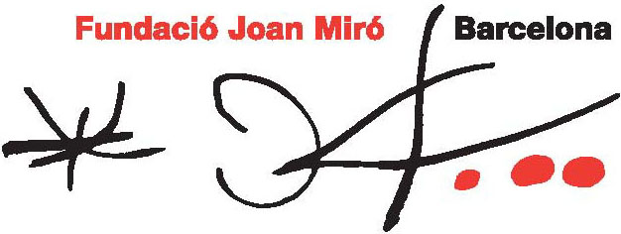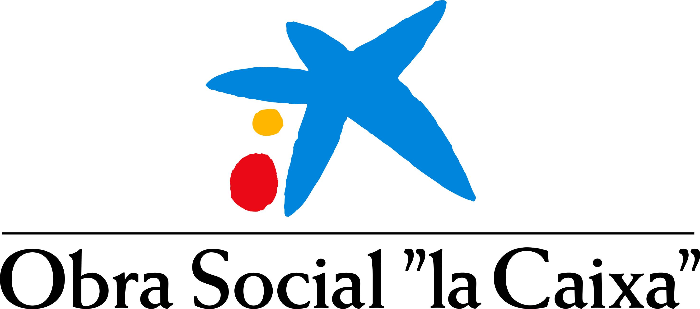

2011 JOAN MIRÓ PRIZE

MONA HATOUM, winner of the 2011 JOAN MIRÓ PRIZE.

The jury of the 2011 Joan Miró Prize has granted the award to the Palestinian-British artist residing in London and Berlin, Mona Hatoum, for her great skill in connecting personal experience with universal values. Hatoum’s sculptures, installations, performances and videos set her among the most outstanding artists on the international art scene.

The Joan Miró Prize is organised by Fundació Joan Miró of Barcelona in collaboration with Obra Social “la Caixa”, which assumes as its own the agreement existing with Fundació Caixa Girona. It is worth €70,000, awarded biennially, and is one of the highest awards among current art prizes. Previously this prize has been awarded to Olafur Eliasson (2007) and Pipilotti Rist (2009) in recognition of their work.

The prize-giving ceremony will take place in the Fundació Joan Miró auditorium on 7 April and will be attended by the jury and the winning artist. A titanium trophy specially designed by André Ricard and inspired by natural forms, will be presented to the winning artist during the event.

The jury for the Joan Miró Prize 2011 is comprised of Alfred Pacquement, director of the Musée National d’Art Moderne, Centre Georges Pompidou; VicenteTodolí, former director of the Tate Modern; Poul Erik Tøjner, director of the Louisiana Museum of Modern Art, and Rosa Maria Malet, director of Fundació Joan Miró.

The jury was unanimous in their decision to award the 2011 Joan Miró Prize to Mona Hatoum because she “has pioneered in opening up art practices to non-Western realities while showing the connections between Western high culture and transnational political and cultural events. After Hatoum, the art world has become a far more open and less self-centred arena, a process that is still in expansion and consolidation. Hatoum’s commitment to human values of concern to all cultures and societies is similar to Miró’s view of mankind after his experience of three devastating wars”.

Upon learning of the jury’s decision, the artist declared: “I am extremely honoured to have been chosen as the recipient of this year’s Joan Miró Prize. Reading the Jury’s statement was a heartening experience. I am sincerely grateful for their very appreciative comments and appraisal of my work and for attributing a great significance to my contribution to the art world”.

Mona Hatoum has exhibited her work at the world’s most important museums and centres of art such as the MoMA, in New York, the Tate, in London, and the Centre Georges Pompidou, in Paris. Her exhibition at Fundació Joan Miró in Barcelona, which will be held in June 2012, will also be sponsored by Obra Social “la Caixa”.

