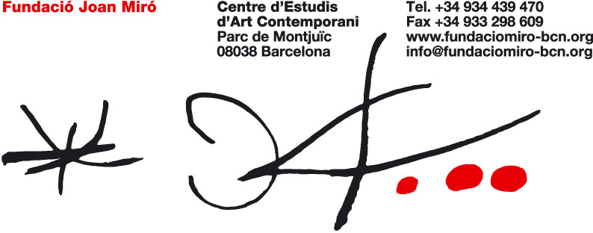

Murals
Contemporary mural practices

19 February – 6 June 2010

Press preview: Tuesday, 16 February, at 12.00
Opening: Thursday, 18 February, at 19.30
A day of artists’ talks: Friday, 19 February, from 10.00 – 18.00

The Joan Miró Foundation presents Murals, an exhibition curated by Martina Millà, head of Projects and Programming at the Foundation. The show offers an overview of the revival of wall painting today and of the great variety to be found in this field.

The exhibition will be a meeting place for mural artists from around the world – from West Africa to Europe, via Mexico and the United States – who have been invited to work on the walls of eleven temporary exhibition spaces.

The curator has selected them basically on the grounds of the artistic merit of their individual works but also because of the dialogues they are able to establish, with a view to creating a visual and conceptual mapping of contemporary mural painting.

The exhibition starts with the most traditional, and anonymous, exponents of mural art – the women from the Coopérative Féminine de Djajibiné Gandega “Djida” (Mauritania), whose work contrasts strongly with the geometrical colour planes of the German artist Lothar Götz. The Olive Tree Patio will house Jerónimo Hagerman’s ivy mural, which can be viewed from inside the building; this is offset by the street art or graffiti by two representatives of UTR Crew, from Bosnia and Herzegovina, and by Scope One from Singapore.

Sakarin Krue-On will be showing Temple, a mural created with spots of white clay on a red ground, which also establishes a counterpoint to Hagerman’s work in the sense that both artists update long-established mural traditions from their respective countries, Thailand and Mexico.
The second half of the exhibition, which begins with the piece by the American graphic designer Brian Rea, who draws with chalk on a blackboard paint ground, alternates between walls in black-and-white and others in which colour predominates. Rea’s work acts as the point of transition towards Nuria y eltono, who generally operate in the street. Their improvisational piece is followed by the black-and-white works of Paul Morrison, and finally by the explosion of coloured wallpaper by Ludovica Gioscia.

The show ends with an interactive piece by Swedish artist Jacob Dahlgren, who involves the public in the creative process: by throwing darts at a wall covered with dartboards, visitors cause the mural to change every day.

The process of creation, which is as interesting in itself as the finished walls, has been photographed and filmed while the artists have been at work in the Foundation. Given the ephemeral nature of mural art, this provides a lasting image in the catalogue and in the short film screened at the end of the exhibition.
Since all the artists will be present in Barcelona, the Foundation is organising a day of artists’ talks with them that will be open to the general public. This will take place on Friday, 19 February, from 10.00 – 18.00 and will include a guided tour of the show.

With this exhibition, the Foundation aims to illustrate the wide variety and forceful presence of the different types of mural art being produced today.

