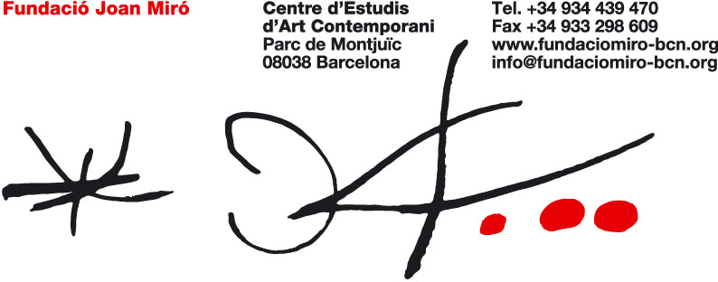

A NEW APPROACH TO JOAN MIRÓ

NEW WORKS ON PAPER
NEW DISPLAY OF THE PERMANENT COLLECTION

The Joan Miró Foundation is adding seventeen new original works on paper, loaned by the Miró family, to its permanent displays. With the assistance of the Catalan Government, it has also remodelled its Permanent Collection.

The Miró Foundation opened its doors in 1975 as a centre for contemporary art where both experts and the general public could come into contact with Miró’s work through the pieces the artist, as well as his friends and relatives, donated to the institution. Together, all these items make up the largest collection of the artist’s work.

The museum holdings have now been extended to include seventeen original works on paper, produced between 1931 and 1953, a loan from the Miró family. Over the years, paper was the material that Joan Miró most frequently used, and he worked with all kinds, from sandpaper and cardboard to newspaper and other printed materials. His artistic output in this medium was innovative and daring. Moreover, the immediacy resulting from working on paper allows for a closer look at the artist’s method.

The new Permanent Collection displays have been made possible thanks to generous funding from the Catalan Government. The new displays technically upgrade all the rooms, most notably with an improved, state-of-the art lighting system.

In addition, the new displays feature wall texts that explain the different techniques used by Miró – from painting and sculpture, to textiles, ceramics, and prints – and place his artistic development within its original historical context: his training in Barcelona, the time he spent in Paris, his relations with the early avant-garde, his interest in experimentation, and the emergence of a highly personal style. The panels are illustrated with images of the artist at different stages of his career to enhance the visitors’ experience and give a more complete understanding of his life and work.

The main pieces on display are also accompanied by short quotes from the artist to help visitors better recognise their relevance in Miró’s artistic development.

A new room for the screening of documentaries on the artist and a browsing station complete the new presentation of the permanent collection.

With its new displays, the Miró Foundation hopes to give a more accessible, yet in-depth view of the work of Joan Miró, an artist rooted in tradition but with a clear vision of things to come, who became one of the most idiosyncratic and influential figures in twentieth-century art.

VISIT THE FOUNDATION
VISIT MIRÓ

Free admission to the Joan Miró Foundation every Thursday between
18 February and 25 March from 5pm – 9pm.

