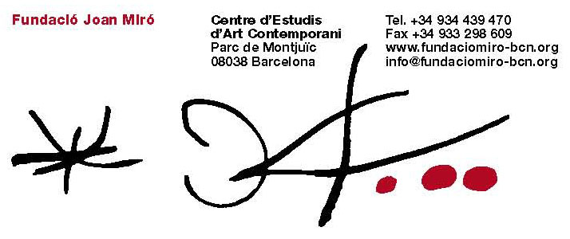

The video-installation Double Light – a dialogue between Pipilotti Rist and Joan Miró – will be added to the Foundation’s collection as a result of a donation by writer and art collector Han Nefkens.

This gift is the first by Nefkens to an art museum in Spain.

Han Nefkens (Rotterdam, 1954) purchases international contemporary art with the express aim of giving it on long-term loan to museums. “For me,” he says, “it’s about much, much more than owning a work of art: it’s about sharing a vision with other people.”

In line with this philosophy, Nefkens has provided support for the production of one of the new works that Swiss video artist Pipilotti Rist is preparing for her forthcoming show at the Foundation, “Pipilotti Rist. Friendly Game – Electronic Feelings”, which will run from 8 July to 1 November 2010. When the exhibition ends, the piece will be included in the Foundation’s collection as a gift from Han Nefkens. He says, “I would be happy to enable the artist who is so close to my heart to make a work especially for the city I have been in love with for so many years. The work by Pipilotti is my dowry to Barcelona.”

Winner of the Joan Miró Prize in 2009, Pipilotti Rist has expressed her admiration for Miró on several occasions, in particular the bold use of colour that she also employs in her art.

Rist articulates this admiration and respect in Double Light, a dialogue with Joan Miró achieved through the projection of a video on to Woman (1968), one of Miró’s sculptures owned by the Foundation. It is an encounter between the two artists that combines their various visual codes.

The first work of art that Nefkens purchased, in 2001, was precisely a video-installation by Rist, which formed the start of the H+F Collection, named after Nefkens and his Mexican partner Felipe. This collection of contemporary art is made up of photographs, videos, installations and paintings by artists of such renown as Jeff Wall, Sam Taylor-Wood, Bill Viola, Shirin Neshat, Felix González-Torres and others. Nefkens has decided to leave the works on long-term loan to museums in the Netherlands and elsewhere, such as the Centraal Museum in Utrecht, Boijmans Van Beuningen in Rotterdam, Stichting de Pont in Tilburg, Huis Marseille in Amsterdam and FRAC Nord–Pas de Calais in Dunkirk, which currently has about 50 of Nefkens works on loan.

Since 2005, Nefkens has mainly bought and commissioned works for specific exhibitions and other projects, either himself or through the ArtAids Foundation and the H+F Collection.

Double Light will remain at the Joan Miró Foundation thanks to the generosity of Han Nefkens, who considers that “Giving is one of the most underrated values in society. By setting up something that I can share with others, I become part of the world. Sharing is the antidote to loneliness. When you share, you are not alone.”

