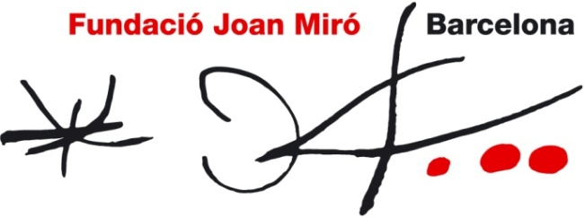

Genius loci
11 March – 5 June 2011

Press presentation: 9 March at 11.30
Opening: 10 March at 19.30

The Joan Miró Foundation presents Genius loci, an exhibition curated by Martina Millà, coordinator of programming and projects that brings together a selection of the latest musical creation of Barcelona.

The title Genius loci refers to the protective spirits that the ancient Romans associated with each city, although it is now more associated with the city’s characteristic and distinctive features. It also refers to the idiosyncratic nature of each creative context, which in this case is Barcelona.

The exhibition is designed as a cross between the experience of listening to a museum audio guide and listening to songs on an MP3 or similar such player. Visitors stroll along the tracks recorded on the player, which spread out in four dimensions.

The Foundation’s temporary exhibition rooms accommodate ten spaces that feature installations, video projections or scenic designs devoted to each group. Upon entering the room, the visitors’ audio guide starts playing the song or the track represented in the space. Each group presents a proposal that complements the experience of listening to its music and is associated with its current creative moment.

The selected groups and their proposals are detailed below, in order of exhibition.

- Hidrogenesse presents Moix, a previously unreleased track that parodies the Book of the Dead and is based in on a fragment of Terenci del Nil (Terenci of the Nile), by Terenci Moix, whom the musicians consider a true “local genius”. The space recreates the Egyptian room of an archaeological museum.

- The room by Mürfila is divided into two spaces that reflect the character of the two main characters, Mürfila and Chari, from the fictional series I Love Ü, which will be shown in the installation.

- Standstill Zoo presents the workspace of Standstill as if it were a cage in a
- zoo. The group will spend some time there practising and writing new songs as visitors look on. The audio guide will play the song “Adelante Bonaparte”.

- With Qui n’ha begut (One Who Has Drunk From It), Mishima reproduces the legendary Heliogàbal, a cult club at which many of the groups in the exhibition have played at some time, as if it were a Duchampian Readymade.

- Internet2 presents Música, el musical (Music, the Musical), the trailer for a musical about the heavenly battle between boring music and Internet2, whose purpose it is to establish a new order to guide the Earth’s music.

- In La casa de la serpiente (The Snake’s Den), Manos de topo invites us to play a board game that illustrates a couple’s passage from love to hate, the classic theme of relationships always present in their songs.

- Els Amics de les Arts invite us to relax and immerse ourselves in an audiovisual installation that reflects their universe and features Jean-Luc as a soundtrack.

- The Pinker Tones have chosen the song Sampléame (Sample me) for the public to do just that: to use different tracks from the song’s original recording to create new mixes.

- With Memegagafloflow, Za! also encourage visitors to participate by experimenting with sound and creating a song along the lines of a Dadaist cadavre exquis.

- Carolina, D.F., an installation by Illa Carolina, is both support act and epilogue and brings the exhibition to a close. They look to the future with their song “No serveix de res fer-se el llit” (There is no point of making the bed).

The selected musicians appear as conceptual artists who are aware of the content of their songs and of how to introduce them and present themselves. Although the styles are diverse, they all involve reflection on what it means to be a musician in Barcelona today. For some, this reflection is manifest in how they stage their work, for others it is in the song lyrics or in recording strategies, and for yet others it is in their completely open tendency to cross artistic disciplines. They are not only musicians, but also heirs to Marcel Duchamp and to Andy Warhol.

The exhibition will be accessible to blind or visually impaired visitors who are provided tactile strips to guide them through the exhibition rooms, special programmes with an exhibition plan in relief, and descriptive texts in Braille on the different installations.

The exhibition comes with a catalogue-CD that features texts by Martina Millà and Kiko Amat, and music, images and texts by each of the groups taking part. There will also be a minisite (http://geniusloci.fundaciomiro-bcn.org) for constant updates of the catalogue, which will include contributions both by the musicians and by visitors, who may upload photos, videos or leave their comments.

