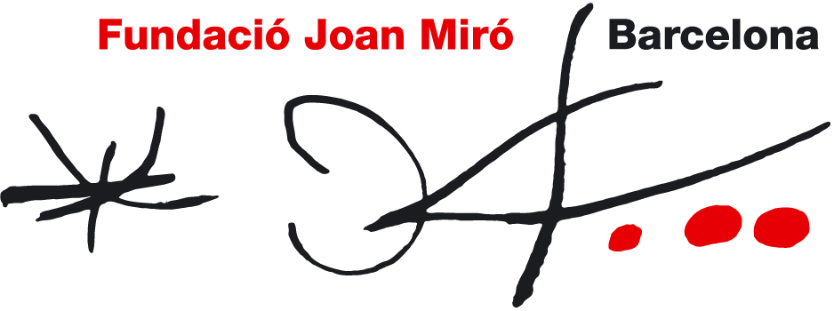

20th April– 3rd June 2012

The Photographs of Joaquim Gomis at the Fundació Joan Miró

With the Joaquim Gomis: From the Oblique Gaze to Visual Narration exhibition, the Foundation presents a photographic legacy from another era.

The exhibition, curated by Juan Naranjo, includes a selection of almost 200 photographs and features one of the most interesting yet least known aspects of Gomis’ work: the fotoscops.

Born in Barcelona in 1902, Joaquim Gomis was one of the first European artists to venture into a new language in photography. He was an active figure in the cultural and artistic life of the educated Catalan bourgeoisie, and produced a broad and powerful body of photographic work in keeping with the most innovative approaches of his time.

Joaquim Gomis: From the Oblique Gaze to Visual Narration includes two distinct areas. The first, The Oblique Gaze, covers photographs taken from 1922 to 1939, when Gomis worked as a pioneer in his field, stepping ahead of the Neues Sehen theorists and producing work that was influential in modern photography throughout Europe. Gomis took many of these photographs during his travels and stays in cities such as Paris and New York.
The second section of the exhibition, Visual Narration, features the fotoscops. In these photographic books, Gomis, together with Joan Prats, developed a unique vision halfway between the language of film and photojournalism. The fotoscops were instrumental in providing insight into the lives and works of major figures in 20th century art such as Joan Miró, Antoni Tàpies, and Antoni Gaudí.
The exhibition gathers fotoscops that were never published, such as Eucaliptus, Barcelona and the series on the female body, as well as others that were published and highly successful such as Atmósfera Miró, Gaudí, Ibiza fuerte y luminosa and Artesanía. This section starts with a selection of photographs, mock-ups, albums, screenings, and photography books to introduce viewers to the innovative narrative concept that Joaquim Gomis and Joan Prats applied to their fotoscops.
Most of the photographs in the exhibition are from the Joaquim Gomis Archive, belonging to the heirs and held by the National Archive of Catalonia. The Joaquim Gomis Archive includes 70,000 images and additional documents including letters, books, and catalogues. The Fundació Joan Miró, the photographer’s grandchildren, and the Generalitat (the Catalan Autonomous Government) signed an agreement according to which the heirs loaned the archive to the Generalitat, which in turn would hold it at the National Archive of Catalonia and delegate management of its use to the Fundació Joan Miró.
Joaquim Gomis, a friend of Joan Miró and Joan Prats, was the first President of the Fundació Joan Miró and a key figure in the initial stages of this organization.
The Fundació Joan Miró has organized a large number of activities related to the exhibition, such as the Mirades singulars (digital camera) and La capsa fotogràfica (pinhole photography) workshops.
The Foundation has also organized tours of the exhibition guided by photographers such as Margarita Andreu, Antoni Bernad, Montse Campins, Joan Fontcuberta, and Professor Manso, who offer a new perspective of Joaquim Gomis’ work.
Joaquim Gomis: From the Oblique Gaze to Visual Narration has received support from the Catalan Government, the National Archive of Catalonia, and the heirs of Joaquim Gomis. Collaborating media include El Periódico, TV3, and Catalunya Ràdio.

A catalogue with texts by Juan Naranjo and Rosa Maria Malet has been published as part of the exhibition project.
Link to flickr featuring works by Joaquim Gomis:
http://www.flickr.com/photos/fundaciojoanmiro/sets/72157626370726566/

